**MANUAL NEW BUSINESS DESKTOP SLA REPORT PROCEDURE**

**Purpose:** The New Business Desktop SLA will be monitored manually until a new monitor is put in place.

1. Each business day, search for Incident tickets in Remedy.

* **Major Outages**

1. In Remedy, click on the “Major Incident Information” tab.
2. Check the “Major Incident” box

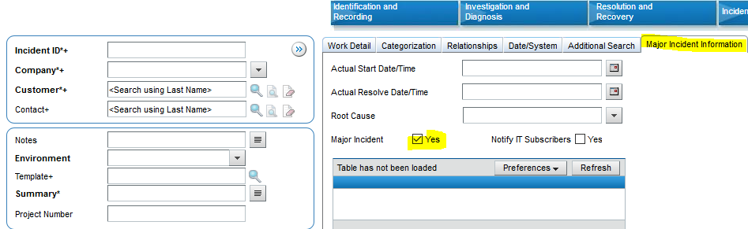

1. Click the “Search” button

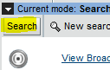

1. The list of “Major Incident” tickets will appear. Look for references to New Business Desktop in the following locations.

* Notes
* Summary
* Service
* Work Detail log

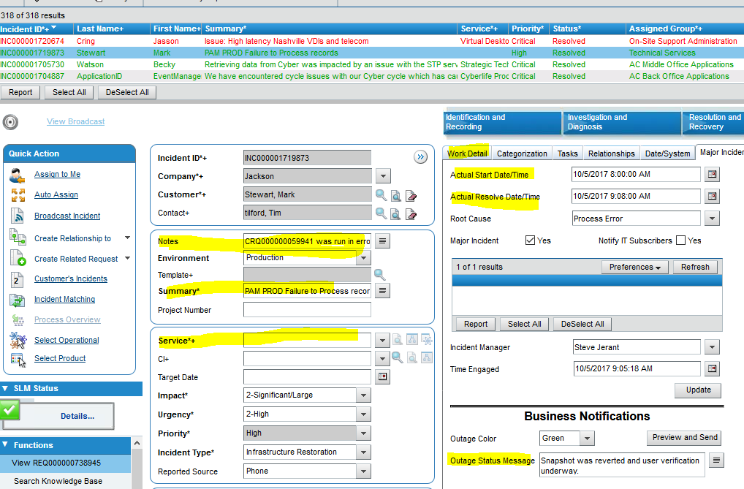

1. If New Business Desktop is noted as being affected by the outage, take note of the following;

* Actual Start Date/Time
* Actual Resolved Date/Time
* Outage Status Message
* **Standard Outages**

1. In Remedy, select “*NBDesktop (NBD) Production”* from the Service*+ list.

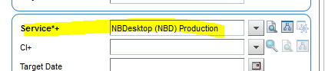

1. Click the “Search” button.



1. A list of tickets will appear. Click on the “Date/System” tab and review each ticket going back to the previous date in which New Business Desktop Incident tickets were last checked.

***Note:*** *On Monday you will have to review back to Friday.*

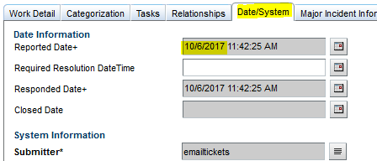

1. Take note of the following:

* Summary
* Notes
* Work Detail log
* Resolution

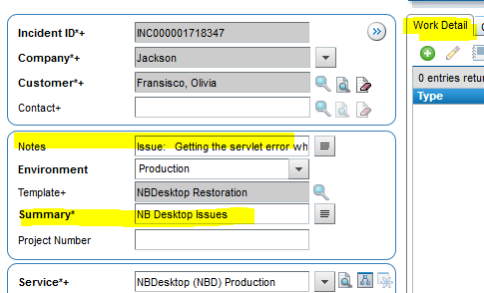

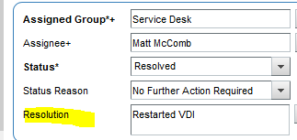

1. Based on the information, you should be able to determine if there was an actual outage or an individual user issue. In the event that an outage is suspected, contact Rob Kolm to verify if there was a true outage or not.
2. If the outage is verified, continue to Step 2.
3. Run the SLA Load Utility.

See the ***SLM_Running the SLA Load Utility Procedure*** for more information.

1. Update the “Details” tab of the NBDesktop SLA Red Green Summary spreadsheet with the following information:

* Incident ticket number
* Duration of the outage
* “Y” if it was a “Major Outage” / “No” if it was a standard outage.

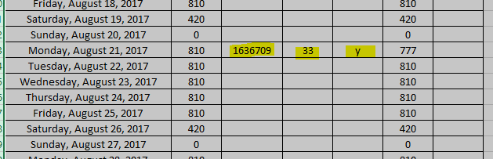

1. Update the SLA Cycle Status Database NBD form in Access.
2. Double click “DB2DBA_SERVICE_HISTORY” under the “Tables” list.



1. Sign in to the SLAP database with your network ID and password.
2. Find the New Business Desktop section of the form, using the Record search at the bottom of the screen.



1. The following data indicates New Business Desktop:

* SLA_ID: “1” indicates that the Service Type is “Availability”.
* SERVICE_ID: “42” indicates that this is the service ID within the SLA system. “42” is the ID for New Business Desktop.
* SERVICE DATE: Locate the date that needs to be updated.

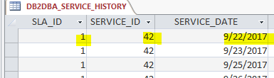

1. Enter outage information in the following fields:

* ERROR COUNT: Type in the duration of time that New Business Desktop was unavailable. This number will appear in the “Error” column on the SLA Report.
* BLACKOUT_COUNT: If it is determined that the outage had a brief impact or no impact at all to the users, add the duration of time in this field. This number will appear under the “Blacked Out” column of the SLA Report.
* OK_COUNT: Take note of the number in this field as it will be used to calculate the daily percentage. Subtract the total of error or blackout minutes from the number in this field. The modified number will appear in the “Verified” column of the SLA Report.
* ACTUAL METRIC: Calculate the daily percentage using the following formula:

OK_COUNT / Original OK_COUNT * 100. This percentage will appear in the “Actual” column.

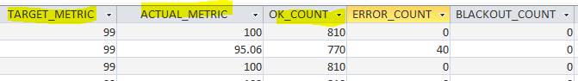

1. Click the “Save” button.

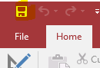

1. Add a comment based on the research done in Step 1 of this procedure.

See the ***SLM_Annotate SLA Outages Procedure*** for more information.

**NOTE: In the event that you have to run the SLA Load Utility for a date in which information was manually entered, the SLA Load Utility will erase the data you entered and you will have to re-enter it in order for it to appear on the report.**